BIOC 455
Lecture # 10– Circadian Clocks: Inputs and Outputs
Lecturer: Dr. Cermakian – January 26th, 2007

NOTE: This NTC is meant to be used as a study aid to supplement your own class notes. Hence, not all of the text or diagrams contained in the lecture slides will be reproduced here.

Please send any comments or questions about NTCs to either Wanda or James through e-mail at u3.represent@gmail.com .

Loose ends from last lecture (Slide 29)
- Delayed Sleep Phase Syndrome
  - This syndrome, as one may expect, delays the onset of sleep.
  - The effects of this syndrome are the reverse of Familial advanced sleep phase syndrome (FASPS).
  - This occurs more often in adolescents
  - No mutation has been yet isolated as a cause for the syndrome, but a mutation is believed to cause the syndrome.
- Seasonal Affective Disorder (SAD)
  - Much more frequent than Delayed Sleep Phase Syndrome (3-10% of the population, depending on country)
  - Patients with this disorder suffer from depression during specific seasons, most often winter.
  - Believed to be associated with the Circadian Rhythm, particularly by the changes in the amount of daylight from one season to another.
- Non 24h sleep-wake syndrome
  - The sleep-wake cycle does not have a period of 24 hours in patients with this syndrome.
  - Very rare
- Health problems of shift workers
  - Body is not able to adapt to the new sleeping schedule
  - Under such conditions, sleeping and mood are greatly affected.
  - Cardiovascular, digestive, and other health problems, including an increased risk of cancer, have also been associated with shift workers.
  - Exposure to very strong light (Several thousand watts) was shown to help nurses adapt to the night shift.
  - Another approach is to remove certain wavelengths of light from the worker’s vision. This was done using orange-tinted goggles to remove wavelengths below 550nm.

The teacher skipped over the next few slides, and are not on the exam

SCN and Cancer (Slide 35)
- It was found that mice with lesions in their SCN possessed greater tumor growth.
- Mice that had been exposed to repeated “Jet Lag” (They changed the day/night schedule constantly) were also shown to have accelerated tumor growth

The teacher then proceeded into the next lecture

Conceptual Components of a Circadian Clock (Slide 2)
- Pacemaker – The SCN measures times.
- Input – Light (Most important).
  - This is the synchronizer of the system.
  - The effects of light on the clock are shown in an Actogram (Slide 3).
  - In humans, τ = 24.2 hours, which is slightly more than the 24 hour day.
  - The light/dark cycle resets the clock, adjusting the human cycle to more accurately fit the current environment. Otherwise, our clock would be slightly off.
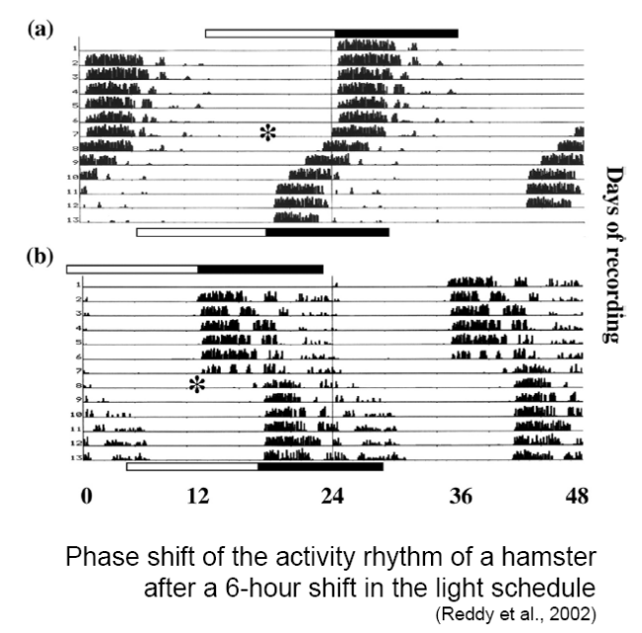
Traveling across Time Zones (Slide 4)
- Travel across time zones shifts the Circadian rhythm left (travel west) or right (travel east) based on differences between the day/night in different regions of the globe. The body takes a little time to adapt to the new environment, and initially retains the circadian rhythm from its previous environment.
- Strong light has been shown to help reset this cycle to the new environment.
- Hamster has been shown to adapt within 4-5 days of a 6 hour shift of the day/night barrier to the left (ie traveling to east 6 hours, or a in the slide). Adaptation occurs much more rapidly when the day/night barrier is shifted forward (ie traveling west 6 hours, or b in the slide). (Slide 5 - Adjacent)

Effect of Short Light Pulses (Slide 6)
- Short light pulses shifts the activity of rodents living entirely in the dark depending on the timing of the pulse.
  - An early night pulse will shift the activity right
  - A late night pulse shifts the activity left

The teacher skipped to Slide 10

Molecular Responses to Light in SCN Neurons (Slide 10)
- A 15 minute light pulse was applied to a rodent during the late part of the night, and the presence of specific proteins in the brain was examined at different time intervals
- A very quick c-fos response was noted within several minutes, peaking at 30 minutes and dissipating within a few hours.
- Changing levels of PER1 and PER2 also occur (Not shown on slide)

Recognition of Changes in Light (Slide 11)
- The retina is the only place in mice and humans that recognizes the light used to regulate the Circadian rhythm
- The layers in the retina are: Outer Nuclear Layer (ONL), Inner Nuclear Layer (INL), Ganglion Cell Layer (GCL), but we were told that we do not need to remember the names.
- The ONL layer is where the cell bodies of all the rods and cones are present.
- Mice were engineered with a degeneration of the ONL layer
  - These mice would have no rods or cones
  - Mice still responded to changes in light, but at a lower efficiency.
  - Cones and rods where therefore not the key element in the recognition of light.
- Mice were engineered with a knock out of Melanopsin
  - Melanopsin is a G-protein coupled receptor, similar to the opsins found in the cones and the rods. This protein was found to be expressed in ganglion cells.
  - The ganglion cells connect the rods and cones to the nervous system and project into the SCN
  - Mice with a KO in the Melanopsin gene still responded to changes in light, but at a lower efficiency.
  - Melanopsin was also shown not to be the key element in the recognition of light.
- Mice were engineered with a KO in both cones/rods and Melanopsin
  - These mice expressed no phase shifting due to changes in light.
  - There must exist a functional overlap
- OPN – Region of the brain that controls pupillery constriction in the presence of strong light
- SPZ – Inhibition of locomotor activity (also called masking)
  - Causes mice to run if exposed to light while previously in the dark (Ie in fear of predators)

Non-photic Cues (Slide 12)
- Light is not the only input to the Circadian Rhythm
- Serotonin, Neuropeptide Y, and activity (among other things) all affect the clock.
- Different brain regions can signal to the SCN (Slide 13 – was not elaborated on beyond this statement)

Circadian Output – Physiological Rhythms (Slide 14)
- Many different parts of the body are affected by the clock, including body temperature, cortisol, somatotropin, potassium excretion, etc.
- Slide 16 is a table listing numerous factors affected by the clock, which is not necessary to know.

Integration of SCN into signaling (Slide 17)
- The SCN projects into many different regions of the brain (Slide 17). It is not necessary to memorize this slide. The SCN signals the pituitary gland and thalamus, among others, through various pathways
- Examples
  - Corticosterone (Cortisol in humans) has a maximum at the beginning of the activity period
  - Melatonin is produced in the pineal gland (Its main role), which needs to be signaled by the SCN in order to produce the melatonin, specifically during the night (Slide 17/18)
    - SCN lesioned animals cannot produce melatonin
  - Hypocretin neurons (Hcrt) may be controlled by SCN, and thus part of the sleep-wake cycle (Slide 19)

Clock/Bmal1 Activity (Slide 20)
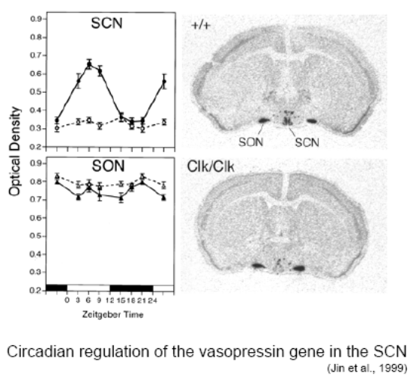
- The activity of Clock/Bmal1 varies according to the rhythm, as should be the mRNA they help transcribe.
- Mice with mutations in the Clock gene (Clk/Clk) have less vasopressin in the SCN than wild type mice, while the amount of vasopressin present in the SON is not altered (Slide 21 - Adjacent)
- The production of vasopressin is therefore not regulated the same way in different regions of the brain.

Circadian Rhythms in other Regions of the Body
- Per1/2 was shown to have, through an RNA protection assay, similar phases in the Heart, Kidney and Muscle (Slide 23)
- GFP was placed in front of the per promoter in drosophila in order to visualize the activity of the promoter. When individual body parts where separated ex vivo, it was shown that they each had independent clocks from the brain and each other. (Slide 24)
- Similar results were observed when the luciferase gene was placed in front of the Per1 promoter in rats. (Slide 25)
- After lesioning the SCN and monitoring the individual rhythms in the body, it was shown that the SCN is essential to synchronize all of the rhythms, but not to sustain them. The rhythms still occurred even in the absence of a functional SCN. (Slide 27)
- Drosophilia / fish peripheral tissues still responded to light in culture. Feeding also has an effect, and can become an important synchronizer for various organs involved with digestion, for instance.

Clock Control Genes (Slide 28)
- Tried to identify rhythmicity in the gene expression between the SCN and the liver.
- It was shown that the two tissues have in common less than 10% of their rhythmic genes.
- These are the clock genes
- Regulation of metabolic pathways obviously do not follow the same mechanism in the two tissues.

